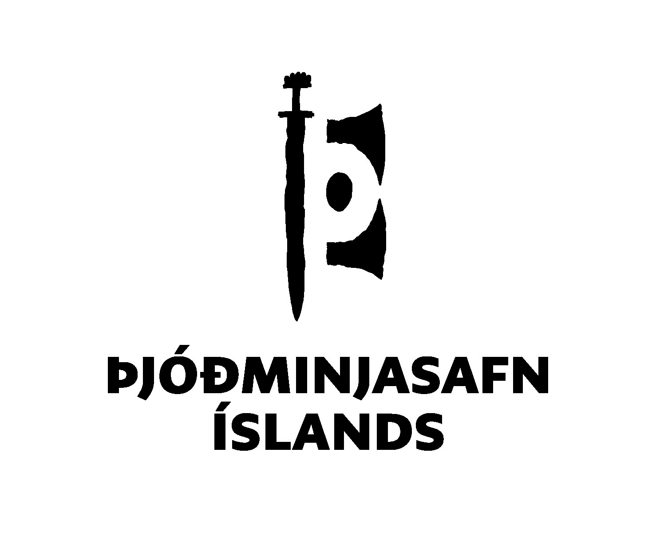 | National Museum of Iceland  Department of Ethnology  Questionnaire no. 139

The Cultural Crucible
Living with Polish roots in Iceland
Please return answers to this questionnaire to polski@thjodminjasafn.is

Dear participant,
The National Museum of Iceland collects oral histories, thereby documenting various perspectives about life in Iceland. Since the 1960s, the museum has posted questionnaires aimed at gaining insight into customs, traditions, and the daily life of Icelandic society. Up to now, questions have primarily been asked in Icelandic. Thus, this questionnaire is designed to collect stories from the large and increasing population of residents with Polish backgrounds.
The answers can be written in Polish, Icelandic, or English. They can be as descriptive and detailed as you would like, as we would like to gain as much information as possible about the topic. You are welcome to use examples from your own experience. You may skip any questions that do not apply to you.
Instructions and terms
You can choose whether your responses are preserved with your name or anonymously. Before you start the questionnaire, we ask you to provide some personal background information. This information will be non-identifiable by name. It is important that you read through the terms below before you provide your answers.
By answering the questionnaire, it is assumed that you consent to the following terms:
I hereby submit my answers to questionnaire no. 139, “The Cultural Crucible. Living with Polish roots in Iceland” to the National Museum of Iceland for preservation. I declare that I am aware of and give my consent for the answers to belong to the National Museum’s database and that the museum uses them for the purpose of research and heritage preservation in the country according to law. This means that the National Museum of Iceland may register the answers in a digital database and make them accessible to the public, scholars, schools, individually or as part of a database, digitally or by other methods that may be implemented in the future.
Thank you for your very important contribution to this research project.
If you require any further information, please call +354 5302276 or email polski@thjodminjasafn.is.

Chapter 1 of 6 – Background information:
Name [optional]:

Gender:

Year of birth:

Address [optional]:

City or municipality:

Country:

What time period do your answers reflect?

Chapter 2 of 6 – Moving to Iceland. This chapter has questions about moving to Iceland. If you were born here, please disregard.

Under what circumstances did you move to Iceland? Did you move for work or education? Did you move to Iceland with a spouse or other family member or to join a spouse or other family member?

What was your situation before moving to Iceland? Were you employed? Studying? Other?

How did you feel when the decision to move to Iceland was made?

What, if anything, did you know about Iceland before moving here? How did you look for information?

What was your first impression when you arrived in Iceland?

How long have you been in Iceland? Do you plan on staying in Iceland?

Has your stay in Iceland had any effect on your personal views, politics and/or cultural behavior? If so, can you please describe how?

Chapter 3 of 6 – Growing up in Iceland – This chapter has questions intended for those who are born in Iceland or moved here in early childhood. If this doesn’t apply to you, please disregard.

Did you ever think about having a non-native background while growing up? Did this affect you? If so, in what way?

Do you speak Polish? Do you use Polish in your day-to-day life? Under what circumstances do you speak Polish?

Do you plan on moving to Poland? If so, would that be permanent or temporary?

How do you feel about your Polish background? Is it a matter of pride, shame, or irrelevance? Have your feelings changed over time?

Do you think your Polish background was important for becoming the person you are?

Chapter 3 of 6 - Living in Iceland

Can you describe your daily life in Iceland? What do you do? Do you go to the swimming pools, the library, cinema, or theatre? What are your hobbies? What do you eat? The more details you care to include, the better.

What language do you use the most in your daily life? What language do you prefer to use?

What is your favorite and least favorite part of living in Iceland? What do you like the most about living here? What was most difficult to get used to?

Do you celebrate Icelandic holidays? Have you adopted any Icelandic traditions or customs?

Do you celebrate Polish holidays, or do you practice any Polish traditions? If so, how have you incorporated them into your daily life in Iceland?

How do you spend your vacations? Do you travel around Iceland? Do you travel to Poland? Do you go on vacations to any other countries other than Poland?

Do your family or friends visit you in Iceland during vacations?

How often do you go to Poland? What is your main reason for traveling to Poland? Is it to visit family and friends? For work? Other reasons?

Chapter 4 of 6 – Being Polish in Iceland

How involved are you with the local Polish community? Do you participate in any Polish community activities?

Do you socialize with other people with Polish backgrounds? If so, do you do that privately or through organized events (e.g. the Polish community in Iceland, the Catholic Church or other)?

Does your background (nationality, religion etc.) attract attention from the people living in your area? If so, in what way?

Do you experience any discrimination in Iceland? If so, can you please explain how?

Have you made Icelandic friends? If so, where did you get to know them?

Do you use any Polish media (watch any Polish tv, read books or newspapers in Polish, listen to Polish radio/podcasts)? If so, what media do you use and to what extent? Why is it important to you?

Do you use any Icelandic media (watch any Icelandic tv, read books or newspapers in Polish, listen to Polish radio/podcasts)? If so, what media do you use and to what extent? Why is it important to you?

Do you eat traditional Polish food in Iceland? If so, where do you get it? Do you frequent Polish shops? Do you grow your own food? Please explain what and why.

If you have children, do you feel it is important to teach them Polish language, traditions and values? If so, how do you do that? Do you feel it is an asset for your children to have a multicultural background?

Chapter 5 of 6 – Being a non-native speaker in Iceland.

How do you feel living in a country where most people speak another language than your native tongue?

How do you feel when using Icelandic? How do other people react when you use Icelandic? Is there a difference between how Icelanders react and how other non-native speakers react?

How do people react when you speak Polish with other Polish speakers, such as at work or in public? Does this affect when and where you speak Polish? Are there situations where you avoid speaking Polish?

Are you learning Icelandic? If so, how? Are there any Icelandic courses in your local community? How do these fit your needs and schedule?
How do you coordinate learning Icelandic with your day-to-day life? Can you describe what is easy/difficult about it?

Chapter 6 of 6 – Final remarks
Is there anything you would like to add that has not been covered so far?
Do you have any remarks or comments on this questionnaire?

